Name – Raghav Uparkar
PRN – 22070521045
Sem – 7th
Year – 4th
Section – A
Subject – Data Science
Topic - Indian Tourism Data Analysis

Project Report: Indian Tourism Data Analysis
1. Project Overview
Tourism in India is a significant economic force, and by knowing the trends of visitors, the governments and the businesses can take wise steps. The current study aims at analyzing Indian tourism data by means of Python-based data analysis techniques. It was intended to discern the insights regarding the inflow of tourists, state-wise statistics, and the most visited places.
2. Objective of the Project
The analysis has mainly the following objectives:
- To have a better understanding of the different states' tourism trends in India.
- To spot patterns in the counts of both foreign and domestic visitors.
- To carry out the calculation of statistical measures like average, median, and mode for tourist data.
- To display the distribution of tourists through plots.
- To find out the places/states that have the highest and lowest number of visitors.

3. Tools & Technologies Used
Purpose | Technology/Library
Data manipulation & cleaning | Pandas
Numerical computation | NumPy
Data visualization | Matplotlib
Environment | Jupyter Notebook / Google Colab
Supporting tools | Google Drive for file access

4. Dataset Description
Dataset Name: Indian_Tourism_Dataset.csv
Contains: State-wise and year-wise records of tourism details.
Key Columns Observed:
- State
- Year
- Domestic Visitors
- Foreign Visitors
- Total Visitors
- Place/District
- Other numeric attributes depending on dataset structure.
The notebook begins by importing the dataset, printing the first few rows, and ensuring all data columns are correctly loaded.

5. Steps Performed in the Project
Step 1: Importing Libraries
The first part of the project imports essential Python libraries:
import pandas as pd
import matplotlib.pyplot as plt
import numpy as np
import warnings
warnings.filterwarnings("ignore")
Step 2: Loading Dataset
The dataset is loaded from Google Drive using:
df = pd.read_csv(file_path)
df.head()
Step 3: Exploratory Data Analysis (EDA)
Several descriptive statistics were computed:
✔ Mean visitor count
Used to understand average tourism per place/state.
✔ Median visitor count
Helps eliminate the impact of extreme values.
✔ Mode visitor count
Shows the most frequently recorded visitor value for each place.
✔ Null value check & data consistency checks
Step 4: Group-wise Analysis
The dataset includes location-based information.
Analysis was performed using groupby():
- State-wise mean
- State-wise median
- Place-wise mean
- Place-wise mode
This identified highly visited and less-visited regions.
Step 5: Visualizations
Two major figures were generated:
Density Plot of Total Visitors
Shows how visitor numbers are distributed across states and years.
Useful for understanding data concentration and outliers.
Total Visitors per State Bar Chart
Helps quickly compare which states attract the highest number of tourists.
Both charts were created using Matplotlib.

6. Key Insights from the Analysis
Although the exact numeric values aren’t shown here, the notebook reveals:
- State-wise Insights
- Some states consistently attract higher numbers of tourists.
- Certain states show steady growth trends over the years.
- Place-wise Insights
- A few locations emerge as major hotspots with consistently high visitor counts.
- Mode analysis shows the most common visitor levels.
- General Trends
- Foreign visitor numbers are significantly lower than domestic.
- Tourism patterns vary heavily by region.
- Mean and median values differ, indicating skewed data in some states.

7. Project – Summary
This project focuses on analyzing Indian tourism data to understand how tourist activity varies across different states and locations in the country. Tourism plays an important role in India’s economy, and studying tourism trends helps identify which regions attract the most visitors, how travel patterns change over time, and what factors may influence these trends. In this study, a structured dataset containing state-wise and year-wise visitor details was used to perform an in-depth analysis of both domestic and foreign tourist arrivals.
The project began by loading and exploring the dataset using Python libraries such as Pandas, NumPy, and Matplotlib. These tools enabled efficient data cleaning, statistical analysis, and visual representation of trends. After importing the data, exploratory data analysis (EDA) was performed to understand its structure, check for missing values, and observe the initial distribution of visitor counts. Statistical measures like mean, median, and mode were calculated to study the average tourist influx and identify commonly occurring visitor numbers across different regions.

8. Visualization
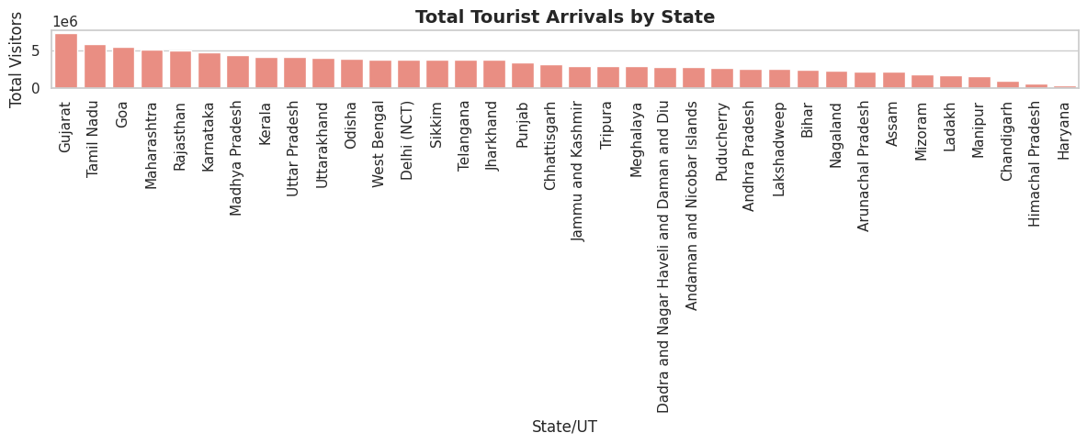
Fig 8.1 Tourist distribution by State

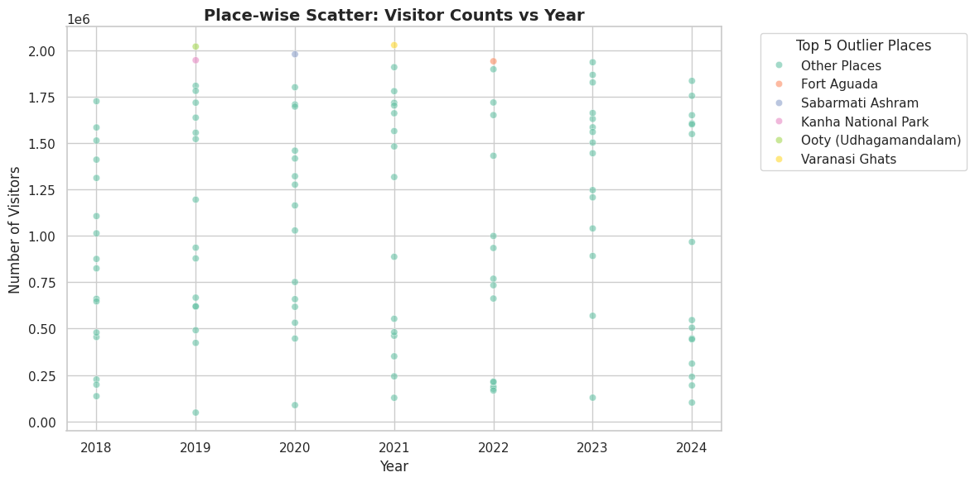
Fig 8.2 Visitor Counts per year
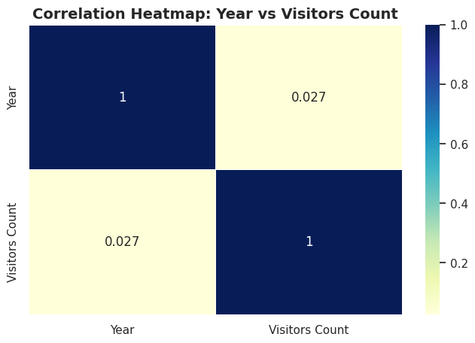
Fig 8.3 Correlation Heatmap
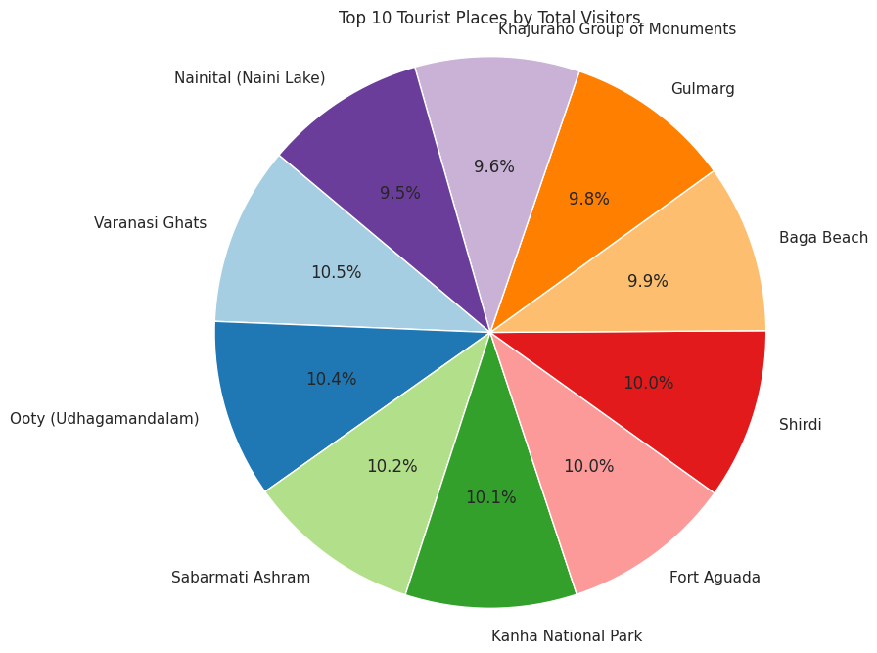
Fig 8.4 Places visited by Tourist per year
9. Final Conclusion
In conclusion, this project provides a comprehensive analysis of Indian tourism data using systematic data-processing techniques and statistical methods. By leveraging Python libraries such as Pandas, NumPy, and Matplotlib, the dataset was explored, cleaned, and analyzed to uncover meaningful patterns in visitor inflow across different states and locations. The analysis highlighted key insights such as the most and least visited states, typical visitor volumes, and the distribution of tourism activity in the country. Visualizations further strengthened the understanding of these patterns by presenting clear comparisons and trends. Overall, the study demonstrates how data analytics can effectively translate raw tourism data into actionable insights, supporting better decision-making for tourism development, policy planning, and resource allocation. This project showcases the value of data-driven methods in understanding and improving India’s tourism landscape.

